Chapter VI

Chemical and Physical Properties of Meat of Bulls and Steers Fed Mycorrhizal or Conventional Corn

P. G. Peiretti^{1,*}, S. Tassone², G. Masoero³
and S. Barbera²
¹Institute of Sciences of Food Production, National Research Council, Grugliasco, Italy
²Department of Agriculture, Forestry and Food Sciences,
University of Torino, Grugliasco, Italy
³Academy of Agriculture, Torino, Italy

Abstract

Arbuscular mycorrhizal based bio-fertilizers are an emerging tool for a sustainable intensive crop culture such as corn. The study aimed to compare the retail yield quality of meat from young bulls and steers fed diets based on mycorrhizal (Myc) and conventional corn (Conv). The trial was carried out on the meat of 10 steers received a Myc corn diet, 10 steers and 10 bulls received a conventional corn diet. The chemical composition of meat, in particular the fatty acid (FA) profile and the rheological characteristics, such as meat cooking shrinkage, together with the Vis-NIR-IR properties of the thawed and the freeze-dried specimens (by means of a pocket SCIO Molecular Sensor) were evaluated. This first study of Myc corn on new feed functionalities has led to unexpected results. The pentadecanoic and heptadecanoic odd FAs in the lipids of the longissimus thoracis muscle may appear as a sign of the adopted “eco-symbiotic” feeding system, perhaps because of an enhancement of the ruminal factor. The improvement in the water holding capacity retail quality traits, promoted by Myc corn, could be explained by other compounds that protect the proteins and lipids from oxidation processes and the muscular fibres from water relaxation. The effect of castration led to the already well-known retail quality improvements in cooking, color and FA profile. A broth examination, by means of a simple colorimeter, can offer useful information about the differences in sex of animals, but also about the use of Myc corn. A small number of raw samples, scanned by means of Vis-NIR-IR instruments, allow the feeding system of a lot to be discriminated, and in this context a pocket SCIO NIR device could be useful.

Keywords: piemontese cattle, meat quality, penta-to-heptadecanoic acid ratio, broth, vibrational spectroscopy

Introduction

As the production of 1 kg of meat can require between 3 and 10 kg of grain (Tilman et al., 2002) the search for the sustainability of the main cereal crops that can be used for meat production has led researchers to explore the possibility of achieving a mutual fruitful symbiosis with the rhizosphere. Arbuscular Mycorrhizal (AM) based bio-fertilizers are emerging tools for improving the sustainability of intensive corn culture. One of the important effects of AM on crops is an increase in the macro and micro mineral absorption (Willis et al., 2013), especially phosphorus (Berruti et al., 2015). Their physiological impact on the corn crop is so strong that it leads to a basic substantial lowering of the in vivo raw pH of the stem, which in turn allows significant yield improvements (Masoero and Giovannetti, 2015). As far as nutrient quality is concerned, the prominent aspects pertaining to corn grain regard the antioxidant
compounds (Berta et al., 2013), while those pertaining to hay concern palatability and digestibility (Sabia et al., 2015). In a study on corn fertilized by microbial consortia with Mycorrhizae (Myc) fed to Italian Friesian dairy cows for 100 d, Chiariotti et al. (2015) observed an improvement in the milk protein content (+6%) and in the overall conditions of the animals, which was confirmed by a higher dry matter intake (+6%) and an average daily gain (+118%). To ascertain whether Myc corn modifies beef retail yield quality, an experiment has been carried out to compare it to conventional corn diet and to assess the biological consequences of a systematic AM bio-fertilization of the corn crop, in a framework of a specialized, so-called “eco-symbiotic” beef supply chain.

Material and Methods

The trial was carried out on the meat of 30 Piemontese cattle: ten steers (SCon) and ten bulls (BCon) received conventional corn diet, while ten steers (SMyc) were fed with a mycorrhizal corn diet, issued from crops bio-fertilized by a complex microbial consortium with Mycorrhizae (Micosat F®), which has been fully described by Zoppellari et al. (2014). A 3 cm thick sample of longissimus thoracis (LT) muscle, was collected from the left side of each carcass, between the 9th and 11th rib, was vacuum-packed, kept for a total of 7 days at 2-4°C, and was then divided into two parts and frozen. One of the parts was destined for qualitative determination and VIS-NIR-IR examinations; the other one was freeze-dried for chromatography analysis to determine the fatty acid (FA) profile. Rheological traits of the meat were measured to assess the water holding capacity (WHC) and the WHC_{trend}, the meat cooking shrinkage (MCS) and the Stress Resistance and Relaxation (SRR), taking into account: thawing loss, total water loss, drip loss, total cooking loss, cooking loss, cooling loss and residual water (Prandi and Barbera, 2009). Samples were thawed for 48h at 2-4°C, and the thawing loss was measured as the percentage of liquid lost during thawing. The meat pH was measured in the laboratory
using a Crison pH25+ (Crison Instruments, S.A., Alella, Spain), equipped with an electrode and an automatic temperature compensator. The drip loss was expressed as the weight lost from the muscle sample (40x40x10 mm), which was kept at 4°C for 48 h in a double bottom plastic container. The WHC_{trend} was determined under a compression of 500N as the total area, and measured by means of 41 visual imaged areas, during a period of 600s; three parameters were obtained from the following equation:

area = k + k₁*time + k₂*Ln(time) (1)

which describes the time-dependent water release over time, where “k” or the intercept is the meat area observed immediately after a compression of 250 mg was started at time = 0s; “k₁” is the linear coefficient of the slope; “k₂” is the coefficient indicating the convexity of the curve till the maximum value (Hofmann et al., 1982; Barbera, 2009). A fourth parameter was the total area at the end of the compression. The warming losses were then measured on the dripped sample, by first considering the fluid lost during 10 min of cooking, until a pre-fixed internal temperature of 70°C was reached (cooking loss), and the cooked samples were cooled at room temperature for 20 min (cooling loss). The total cooking loss (TCL) was calculated as the sum of the two components (Barbera and Tassone, 2006). The residual available chewing water in the cooked meat (residual water, according to Barbera and Grigioni, 2014) was obtained through compression of three small cylinders (Ø 10 mm), extracted from the sample used for the MCS; these cylinders were compressed to measure tenderness according to the SRR method and the difference in weight before and after compression indicated the water still available to the consumer for chewing the cooked meat. MCS, which expresses the shrinkage in the meat sample area caused by cooking and cooling, was measured using a Video Image Analyser according to the following relationship (Barbera and Tassone, 2006):

MCS = [(raw meat area – cooked meat area)/ raw meat area] x 100 (2)

The intramuscular fat marbling content was assigned visually, and a score of 1 was assigned to meat without marbling fat and 5 to meat with abundant marbling fat.
A broth preparation was obtained by using the residual meat trimmed off during the rheological tests. Twenty grams of muscle were cooked in 100 mL of deionized water at 85°C for 15 min in an agitator at 60 rpm. After 60 min of cooling, the filtered liquid, released from the supernatant, was examined using the two instruments, as described below.
The FA profile, expressed as a percentage of the total FAs, was performed on the lipids of LT according to Peiretti and Meineri (2008). The analysis was carried out by means of gas chromatography, using a Dani GC 1000 DPC (Dani Instruments S.P.A., Cologno Monzese, Italy), equipped with a fused silica capillary column - Supelcowax-10 (60 m x 0.32 mm (i.d.), 0.25 μm). The injection and flame ionization detector (FID) ports were set at 245°C and 270°C, respectively. The oven temperature program was set at 50°C for the first minute, and then increased at a rate of 5°C/min till it reached 230°C, where it was maintained for 24 min. Hydrogen was used as the carrier gas, at a flow rate of 5 ml/min. The gases used in the FID were hydrogen and purified air, and were produced by a zero air generator (UHP-10ZA, Domnick Hunter Scientific, Tyne and Wear, England), combined with nitrogen as the make-up gas. One microliter was injected using a Dani ALS 1000 auto sampler with a 1:50 split ratio. The peak area was measured using a Dani Data Station DDS 1000, and each peak was identified and quantified according to pure methyl ester standards (Restek Corporation, Bellefonte, PA, USA).
The Visible reflectance radiation of the thawed meat was evaluated in the 360 to 740 nm range by means of a Spectrophotometer CM-600d (Minolta Camera Co., Tokio, Japan), using a standard white tile (Illuminant D65, 10° Observer) in the CIELAB system (L*, Lightness; a*, redness; b*, yellowness; Chroma and Hue), by taking three readings for each sample, which consisted of a 1.3 cm thick slice of meat, after 60 min of exposure to the environmental temperature. Vibrational analyses were performed in reflectance mode on thawed and freeze-dried specimens using an IdentiCheckTM FT-NIR-IR system (PE, Perkin-Elmer, Beaconsfield, England) in the 714-3333 nm range, with 2751 absorbance points, as described in Tassone et al. (2014).
The broth was examined for color properties in reflectance mode, by means of the Spectrophotometer CM-600d, using a 20 mm deep quartz cuvette. For the NIR-IR examination, the broth was put into a 10 mm high Petri cup, and the spectra were then captured in transflectance mode, from the lower surface, with the upper blank overlaying the mirror in contact with the quartz, thus a thin layer of liquid was trapped in-between; 60 scans were registered and averaged. Freeze-dried samples were also examined by means of a pocket SCIO Molecular Sensor (Consumer Physics Inc., Tel Aviv, Israel), a new miniaturized web-based wireless device that was used to examine the samples in the 740-1070 nm NIR range, with 331 absorbance points; four spectra were replicated for each sample.
A univariate model was applied to assess the effects of the three levels and two pairwise differences (SMyc vs SCon and SCon vs BCon) expressed as LSMeans were tested by the PDIFF test. Univariate data analyses of 51 parameters were performed by means of the GLM procedure of the SAS/STAT software package (SAS, 2016).

Results and Discussion

A significant increment in the ultimate muscle pH (5.64 vs 5.52; +2%; P = 0.0123) was registered in the SMyc group (Table 1). The ultimate muscular pH is a rather stable parameter as it depends on muscle dimorphism, stress factors and some functional feeds (Adeyemi et al., 2015). The elevation of the pH in SMyc is a crucial point. Whether it was derived from a lack of glycogen in the LT muscle (Hamm, 1977), or it resulted from a higher buffering capacity of the muscle, the net result was a basic improvement in the WHC, as pointed out by the final water area reduction (WHC_{trend}-total water: -3%; P = 0.0132). WHC_{trend} exhibited a typical parabolic trend (Figure 1).

Table 1. Rheology parameters in the longissimus thoracis muscle

Parameters |  | LSMeans |  |  | RMSE | P value | P value
 |  | SMyc# | SCon£ | BCon$ | RMSE | SMyc vs SCon | SCon vs BCon
Thawing loss | % | 5.01 | 6.81 | 7.91 | 3.22
pH |  | 5.64 | 5.52 | 5.60 | 0.10 | 0.0123 | 0.0736
WHC_{trend} - meat area or k | mm² | 650.1 | 666.9 | 650.0 | 37.56
WHC_{trend} - k₁ | mm²/s | 0.158 | 0.173 | 0.089 | 0.092 |  | 0.0501
WHC_{trend} - k₂ | mm²/Ln(s) | 80.47 | 82.98 | 100.38 | 8.590 |  | <0.0001
WHC_{trend} - total area | mm² | 1248 | 1288 | 1340 | 33.55 | 0.0132 | 0.0016
Total water loss | % | 39.58 | 41.11 | 43.25 | 4.53
Drip loss | % | 5.56 | 5.49 | 5.76 | 2.57
Total cooking loss | % | 22.67 | 23.16 | 28.11 | 3.26 |  | 0.0009
Cooking loss | % | 15.79 | 17.75 | 23.34 | 3.49 |  | 0.0013
Cooling loss | % | 6.88 | 5.41 | 4.77 | 1.57 | 0.0456
Residual water | % | 16.9 | 17.96 | 15.14 | 3.34 |  | 0.0694
Meat cooking shrinkage | % | 15.39 | 16.44 | 15.86 | 4.23
Fat score§ | No. | 1.4 | 1.3 | 1.1 | 0.43
Tenderness | N | 18.44 | 19.09 | 20.2 | 5.53
Data are expressed as LSMeans. # SMyc (Meat of mycorrhizal fed steers). £ SCon (Meat of conventional fed steers). $ BCon (Meat of conventional fed bulls). § Fat score range: 1 absent - 5 abundant fat.

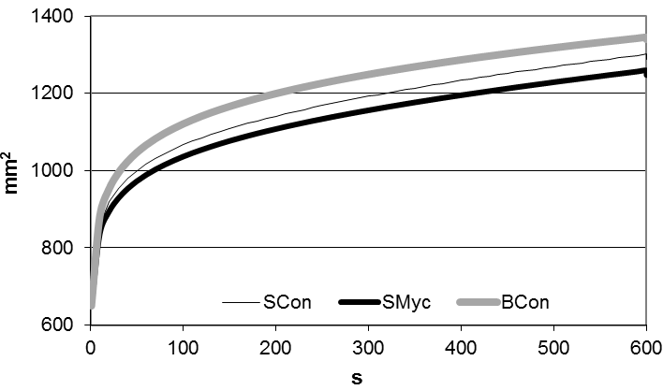
Figure 1. Water holding capacity (WHC_{trend}) in the three groups: SCon (Meat of conventional fed steers), SMyc (Meat of mycorrhizal fed steers) and BCon (Meat of conventional fed bulls).
The individual parameters of the linear-log function fitted very closely (R² = 0.99), but there was no statistical difference in the shapes between the SCon and SMyc groups. No antioxidant tests were performed in the present experiment. However, in the authors’ opinion, the antioxidant factor could have been involved in a buffering action that prevented myofibrillar protein oxidation, and this led to a decrease in the WHC (Huff-Lonergan and Lonergan, 2005). On the other hand, any increment in antioxidant compounds may lead to inactivation or modiﬁcation of the calpain activity, with a consequent WHC improvement (Adeyemi et al., 2015).
As shown in Table 1, the WHC differences in raw meat were not followed by different cooking properties, except for an increase in cooling loss MCS in SMyc compared to SCon (+27%; P = 0.0456).
A consequence of the pH rise in SMyc was a color opacification that affected the Chroma (-9%; P = 0.0119) and reduced the yellow component (b; -13%; P = 0.0101; Table 2). The broth color parameters were not significantly affected by the Myc factor. The rise in pH and the chromatic reductions of the muscle are in agreement with the results of Page et al. (2001), who observed a negative correlation between pH and b* (r = -0.56) in steers and heifers.

Table 2. Color parameters in the longissimus thoracis (LT) muscle
and broth

Parameters |  | LSMeans |  |  | RMSE | P value | P value
 |  | SMyc# | SCon£ | BCon$ | RMSE | SMyc vs SCon | SCon vs BCon
LT muscle | L* | 38.71 | 40.74 | 46.14 | 3.37 |  | 0.0036
LT muscle | a* | 15.75 | 16.8 | 16.18 | 1.74
LT muscle | b* | 13.53 | 15.53 | 17.36 | 1.62 | 0.0101 | 0.0018
LT muscle | Chroma | 20.86 | 22.93 | 23.79 | 1.72 | 0.0119
LT muscle | Hue | 40.50 | 42.89 | 47.15 | 4.28 |  | 0.0346
Broth | L* | 8.49 | 8.48 | 15.20 | 4.61 |  | 0.0030
Broth | a* | -0.65 | -0.72 | -0.90 | 0.23 |  | 0.0830
Broth | b* | 0.42 | 0.50 | 1.61 | 1.04 |  | 0.0239
Broth | Chroma | 0.93 | 0.94 | 2.02 | 0.88 |  | 0.0106
Broth | Hue | 155.5 | 157.0 | 140.9 | 31.52
Data are expressed as LSMeans. # SMyc (Meat of mycorrhizal fed steers). £ SCon (Meat of conventional fed steers). $ BCon (Meat of conventional fed bulls).

In the meat color examination, the SCon group (Table 2) appeared less lucent (L), less yellow (b*) and less saturated (Hue) than the BCon group. Such a difference was amplified in the visible spectra of the broth, because the steers showed lower lightness, yellowness and chroma values. However, Purchas et al. (2002) observed an increase in yellowness (b*; 6.0 vs 5.1; +18%) and in redness (a*; 14.5 vs 13.3; +9%) in Angus steers, with a significant decrease in pH (-3%), but no variation in lightness. The very different and low values of the color parameters that can be observed in Angus should be pointed out; these are derived from marbling, a factor that is totally absent in the double muscled Piemontese breed, which induces a very intense coloring.
The properties of the water in muscle resulted to be modified significantly after castration (Table 1). The meat area (intercept) and the linear component of the WHC_{trend} were similar, but the Log-component in steers was reduced by 20% (P < 0.0001) and the final total area of WHC was reduced by 2% (P < 0.0016), as highlighted in Figure 1.
The cooking properties were improved in the steers, as a consequence of the higher WHC. The total cooking losses were reduced, and were especially limited during cooking, while they increased during cooling. These results agree with a previous study on Piemontese cattle (Destefanis et al., 2003) in which early castrated steers vs bulls registered a significant decrease (-9%) in cooking losses. Also Purchas et al. (2002) observed lower cooking losses in Angus steers vs bulls.
The FA composition of the LT muscle is reported in Table 3 and highlighted in Figure 2. The FA composition of the SMyc group, when compared to SCon group, was characterized by an increase in the monounsaturated vaccenic acid (P = 0.0041) as well as in the saturated myristic acid (P = 0.0012) and in the odd pentadecanoic acid (P = 0.0050), but also with a decrement in the odd heptadecanoic acid (P = 0.0021). In fact, the penta-to-heptadecanoic ratio value of 1.17 in the SMyc group was 77% higher than in SCon group (P = 0.0021). The FA profile of the meat of steers and bulls fed conventional corn (SCon vs BCon) was characterized by significant differences in: stearic, oleic, palmitoleic, α-linolenic, saturated and monounsaturated FAs, and α-linolenic-to-linoleic ratio.

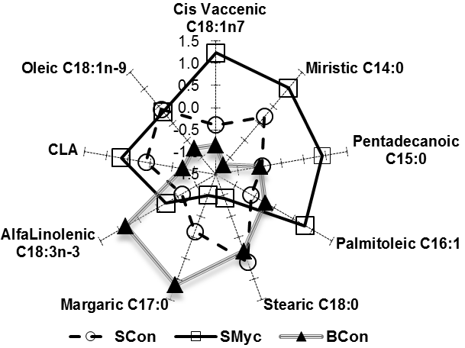
Figure 2. Normal radar plot of the fatty acid profile in the three groups: SCon (Meat of conventional fed steers), SMyc (Meat of mycorrhizal fed steers) and BCon (Meat of conventional fed bulls).
Table 3. Fatty acid (FA) composition (% of total FA) in the longissimus thoracis muscle

Parameters | LSMeans |  |  | MSE | P value | P value
Parameters | SMyc# | SCon£ | BCon$ | MSE | SMyc vs SCon | SCon vs BCon
Myristic acid (C14:0) | 3.37 | 2.57 | 2.34 | 0.49 | 0.0012
Pentadecanoic acid (C15:0) | 0.61 | 0.47 | 0.46 | 0.10 | 0.0050
Palmitic acid (C16:0) | 24.0 | 22.9 | 24.4 | 1.80 |  | 0.0667
Palmitoleic acid (C16:1) | 3.84 | 3.07 | 1.77 | 0.91 | 0.0704 | 0.0037
Heptadecanoic acid (C17:0) | 0.52 | 0.85 | 0.79 | 0.22 | 0.0021
Stearic acid (C18:0) | 17.58 | 20.31 | 24.35 | 3.15 | 0.0632 | 0.0080
Oleic acid (C18:1n-9) | 35.56 | 35.78 | 32.14 | 3.17 |  | 0.0160
Vaccenic acid (C18:1n-7) | 1.23 | 0.67 | 0.82 | 0.40 | 0.0041
Parameters | LSMeans |  |  | MSE | P value | P value
Parameters | SMyc# | SCon£ | BCon$ | MSE | SMyc vs SCon | SCon vs BCon
Linoleic acid (C18:2n-6) | 6.33 | 5.96 | 6.63 | 1.27
α-linolenic acid (C18:3n-3) | 0.66 | 0.59 | 0.83 | 0.17 |  | 0.0030
Conjugated linoleic acids | 0.62 | 0.52 | 0.37 | 0.18 |  | 0.0718
Unknown fatty acid | 5.72 | 6.34 | 5.09 | 2.23
Saturated fatty acid | 46.04 | 47.08 | 52.36 | 3.22 |  | 0.0010
Monounsaturated fatty acid | 40.63 | 39.52 | 34.72 | 3.47 |  | 0.0046
Polyunsaturated fatty acid | 7.61 | 7.07 | 7.83 | 1.44
Penta-to-Heptadecanoic ratio | 1.17 | 0.66 | 0.66 | 0.33 | 0.0021
α-linolenic-to-Linoleic ratio | 0.10 | 0.10 | 0.13 | 0.03 |  | 0.0461
Data are expressed as LSMeans. # SMyc (Meat of mycorrhizal fed steers). £ SCon (Meat of conventional fed steers). $ BCon (Meat of conventional fed bulls).

The penta-to-heptadecanoic ratio has recently been implicated in several healthy frameworks; this is not surprising, since the lipid profiles in humans are involved in some 150 syndromes (Jenkins et al., 2015). A survey on humans showed that the blood level of the saturated pentadecanoic FA was inversely associated with the risk of type 2 diabetes (Ratnayake, 2015). A renewed debate about dairy saturated FAs is still ongoing (Astrup, 2014). As highlighted in Table 4, the average penta-to-heptadecanoic ratio in human plasma is around 0.41. Comparative values, of around 0.4, were found in the lipids of standard poultry meat and in eggs, while the lowest value was detected in salmon fillet (0.18). Conversely, the ratio appeared more elevated (2.15) in cow milk fat and in the related cheese products. These FAs have not always been recovered in ruminant meat: Adeyemi et al. (2015) did not find them in the semimembranosus muscle of goats; Aït-Kaddour et al. (2016) did not find them either in the FA composition of LT. Reports from different authors on cattle muscles make it possible to consider the average value of the penta-to-heptadecanoic ratio as 0.62. The milk level of heptadecanoic acid was proposed by Vlaeminck et al. (2006) as a marker of intake in dairy cattle, to predict the duodenal ﬂow of microbial biomass; this FA showed a close relationship with the microbial matter in the rumen and milk secretion. No rumen examination has been conducted in the present experiment, so only a hypothesis can be made about the evident anomaly of the ratio, which was probably induced by a low level of the heptadecanoic acid. In fact, the ratio value of 1.17, reported in Table 3 for the SMyc group, appears more oriented towards a dairy than a meaty type, and this fact depends on the reduction in the heptadecanoic acid level, with a parallel increase in the pentadecanoic acid. The rumen complex could therefore be responsible for the presence of such an anomaly of the odd acids. In fact, Chiariotti et al. (2015) observed that the protozoa count in rumen liquid from dairy cattle fed Myc were significantly higher than in cattle fed conventional corn (+15.6%; P < 0.05), and was similarly increased the total bacterial count (P < 0.01). No fungal concentration difference was observed.

Table 4. Penta-to-Heptadecanoic ratio (C15:0/C17:0) values in different biological systems

Biological systems | Reference | Origin | C15:0 % | C17:0 % | Ratio | Avg.
Human plasma | Sun et al. (2007) | - | 0.15 | 0.37 | 0.41 | 0.41
Cattle milk | Vlaemink et al. (2006) | - | 1.10 | 0.56 | 1.96 | 2.15
Cattle milk | Pegolo et al. (2015) | Italian Brown Swiss | 1.19 | 0.54 | 2.20 | 2.15
Cattle milk | Frelich et al. (2009) | Czech Fleckvieh & Holstein | 1.09 | 0.44 | 2.48 | 2.15
Cattle muscle | Nikolić et al. (2009) | Leskovac | 0.39 | 1.45 | 0.27 | 0.62
Cattle muscle | Brugiapaglia et al. (2013) | Piemontese | 1.17 | 1.58 | 0.74 | 0.62
Cattle muscle | " | Limousin | 1.14 | 1.53 | 0.74 | 0.62
Cattle muscle | " | Italian Friesian | 1.29 | 1.34 | 0.96 | 0.62
Cattle muscle | das Graças Padre et al. (2006) | Aberdeen Angus Steers | 0.32 | 1.17 | 0.27 | 0.62
Cattle muscle | " | Aberdeen Angus Bulls | 0.43 | 1.34 | 0.32 | 0.62
Cattle muscle | Present paper | SMyc# | 0.61 | 0.52 | 1.17 | 0.62
Cattle muscle | " | SCon£ | 0.47 | 0.85 | 0.55 | 0.62
Cattle muscle | " | BCon$ | 0.46 | 0.79 | 0.58 | 0.62
Salmon fillets | Concollato et al. (2016) | Control stunning | 0.15 | 1.19 | 0.18
Salmon fillets | Concollato et al. (2016) | CO stunning | 0.16 | 1.15 | 0.18
Poultry Broilers | Kralik et al. (2005) | Indoor vs outdoor growth | 0.12 | 0.33 | 0.36
Hen eggs | Škrtić et al. (2007) | Unsupplied FA diet | 0.03 | 0.07 | 0.42
Hen eggs | Škrtić et al. (2007) | Supplied FA diet | 0.23 | 0.25 | 0.92
# SMyc (Meat of mycorrhizal fed steers). £ SCon (Meat of conventional fed steers). $ BCon (Meat of conventional fed bulls).

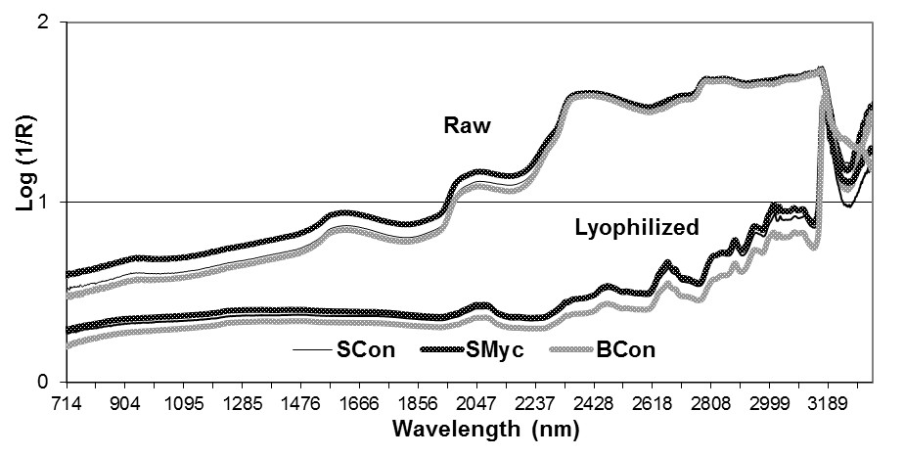
Figure 3. Average NIR-IR spectra of the raw and freeze-dried meat of the three groups: SCon (Meat of conventional fed steers), SMyc (Meat of mycorrhizal fed steers) and BCon (Meat of conventional fed bulls). Selected wavelengths from the Raw meat: Myc: 1322, 1343, 1401, 1454, 1477 and 1513 nm; Sex: 3269, 3280, 3289, 3323 and 3333 nm. Selected wavelengths from the freeze-dried meat: Myc: 857, 858, 892, 903, 910 and 913 nm; Sex: 750, 774, 804, 886, 901 and 903 nm.
The raw meat showed a higher absorbance in the average NIR-IR spectra than the freeze-dried muscle (Figure 3), in agreement with Concollato et al. (2016), who examined salmon samples. The bulls showed a lower absorbance in raw and freeze-dried samples, but a higher absorbance in the broth (Figure 4). The SCIO NIR spectra of the bulls and of the steers showed multiple crossings of the standardized spectra (Figure 5). Cifuni et al. (2016) observed a downward shift in the absorbance of rabbit muscle after ageing from 1 to 6 or to 12 days; moreover, these AA showed that the wavelengths from 380 to 600 nm overall were accurate, at a 0.82 level, in discriminating 1 from 3 and from 6 days classes in ageing rabbits, and this fact was correlated to the TBARS evolution. The water molecules of a matrix are the first target of energy absorption. In fact, when a broth is scanned, most of the signal will be absorbed, and only a
very low reflected signal is returned, even though the optical length is limited to a film between the quartz and the upper blank. Nevertheless, broth contains several compounds that could interact with radiant energy in the visible range.
The best discriminant wavelengths for the Myc and Sex effects are reported in Figures 3 and 4. In the broth examination, the Myc factor was more centered in the 981-1180 nm NIR band, while the Sex effect was identified over the NIR limit (2500 nm) and located in the 3203-3330 IR band. A similar bi-modal path was registered for the raw sample examination. The most representative bands for the freeze-dried samples were located in the first NIR regions for both factors, a region that overlaps the range of the pocket SCIO NIR (740-1070 nm). In a previous paper pertaining to twelve crops (Tassone et al., 2014), the near IR region (2500-3333 nm) was pointed out as the most interesting for the prediction of several compounds.

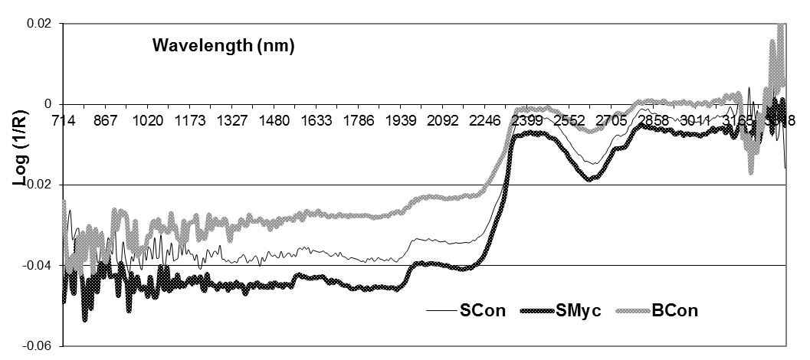
Figure 4. Average NIR-IR spectra of the broth of the three groups: SCon (Meat of conventional fed steers), SMyc (Meat of mycorrhizal fed steers) and BCon (Meat of conventional fed bulls). Selected wavelengths: Myc: 981, 1005, 1100 and 1180 nm; Sex: 3203, 3235, 3268 and 3330 nm.

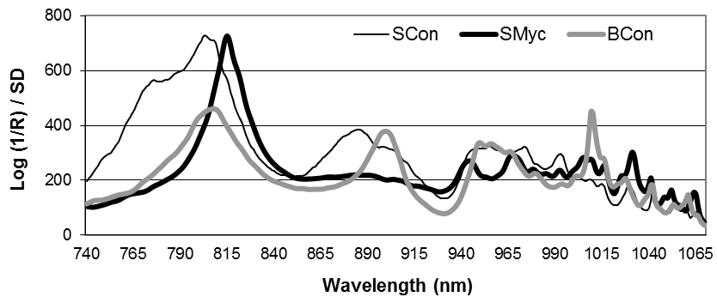
Figure 5. Average standardized SCIO NIR pocket-sized molecular scanner spectra of the freeze-dried meat of the three groups: SCon (Meat of conventional fed steers), SMyc (Meat of mycorrhizal fed steers) and BCon (Meat of conventional fed bulls). Selected wavelengths: Myc: 812, 1014, 1029, 1053, 1054 and 1066 nm; Sex: 743, 891, 956, 1003, 1020 and 1054 nm.

Conclusion

This first study of Myc corn on new feed functionalities has led to unexpected results. The pentadecanoic and heptadecanoic odd FAs in the lipids of the LT muscle may appear as a sign of the adopted “eco-symbiotic” feeding system, perhaps because of an enhancement of the ruminal factor.
The improvement in the WHC retail quality traits, promoted by Myc, could be explained by other compounds that protect the proteins and lipids from oxidation processes and the muscular fibres from water relaxation.
The effect of castration led to the already well-known retail quality improvements in cooking, color and FA profile.
A broth examination, by means of a simple colorimeter, can offer useful information about the differences in the sex of animals, but also about the use of Myc corn.
A small number of raw samples, scanned by means of Vis-NIR-IR instruments, allow the feeding system of a lot to be discriminated, and in this context a pocket SCIO NIR device could be useful.

Acknowledgments

The authors would like to thank Mrs M. Jones for the linguistic revision of the manuscript and La Granda Srl© (Genola, CN, Italy) for the helpful collaboration in the animal and slaughter operations, as well as for the SCIO meat diagnostic developments project.

References

Adeyemi, K. D., Sabow, A. B., Shittu, R. M., Karim, R. & Sazili, A. Q. (2015). Influence of dietary canola oil and palm oil blend and
refrigerated storage on fatty acids, myofibrillar proteins, chemical composition, antioxidant profile and quality attributes of semimembranosus muscle in goats. Journal of Animal Science and Biotechnology, 6, article 51.
Aït-Kaddour, A., Thomas, A., Mardon, J., Jacquot, S., Ferlay, A. & Gruffat, D. (2016). Potential of fluorescence spectroscopy to predict fatty acid composition of beef. Meat Science, 113, 124-131.
Astrup, A. (2014). A changing view on saturated fatty acids and dairy: from enemy to friend. The American Journal of Clinical Nutrition, 100, 1407-1408.
Barbera, S. & Tassone, S. (2006). Meat cooking shrinkage: Measurement of a new meat quality parameter. Meat Science, 73, 467-474.
Barbera, S. (2009). WHC_{trend}, a dinamic parameter based on the filter paper press method to measure water holding capacity in meat. In: Proceedings of the 55th International Congress of Meat Science and Technology, Copenhagen, Denmark, pp. 717–721.
Barbera, S. & Grigioni, G. (2014). A protocol to measure the free water in raw and cooked meat. Archivos Latinoamericanos de Producción Animal, 22, 125-128.
Berruti, A., Lumini, E., Balestrini, R. & Bianciotto, V. (2015). Arbuscular Mycorrhizal fungi as natural biofertilizers: let’s benefit from past successes. Frontiers in Microbiology, 6, 1-13.
Berta, G., Copetta, A., Gamalero, E., Bona, E., Cesaro, P., Scarafoni, A. & D’Agostino, G. (2013). Maize development and grain quality are differentially affected by Mycorrhizal fungi and a growth-promoting pseudomonad in the field. Mycorrhiza, 24, 161-170.
Brugiapaglia, A., Lussiana, C. & Destefanis, G. (2013). Fatty acid profile and cholesterol content of beef at retail of Piemontese, Limousin and Friesian breeds. Meat Science, 96, 568-573.
Chiariotti, A., Zilio, D. M., Contò, G., Di Giovanni, S. & Tripaldi, C. (2015). Effects of microbial maize grain on milk and on rumen environment of Italian Holstein dairy cows. Italian Journal of Animal Science, 14(s1), 144.
Cifuni, G. F., Contò, M. & Failla, S. (2016). Potential use of visible reflectance spectra to predict lipid oxidation of rabbit meat. Journal of Food Engineering, 169, 85-90.
Concollato, A., Parisi, G., Masoero, G., Romvàri, R., Olsen, R. E. & Dalle Zotte, A. (2016). A Carbon monoxide stunning of Atlantic salmon (Salmo salar L.) modifies rigor mortis and sensory traits as revealed by NIRS and other instruments. Journal of the Science of Food and Agriculture, 96, 3524-3535.
das Graças Padre, R., Aricetti, J. A., Moreira, F. B. Mizubuti, I. Y., do Prado, I. N., Visentainer, J. V., de Souza, N. E. & Matsushita, M. (2006). Fatty acid profile, and chemical composition of longissimus muscle of bovine steers and bulls finished in pasture system. Meat Science, 74, 242-248.
Destefanis, G., Brugiapaglia, A., Barge, M. T. & Lazzaroni, C. (2003). Effect of castration on meat quality in Piemontese cattle. Meat Science, 64, 215-218.
Frelich, J., Šlachta, M., Hanuš, O., Špička, J. & Samková, E. (2009). Fatty acid composition of cow milk fat produced on low-input mountain farms. Czech Journal of Animal Science, 54, 532-539.
Hamm, R. (1977). Postmortem breakdown of ATP and glycogen in ground muscle: A review. Meat Science, 1, 15-39.
Hofmann, K., Hamm, R. & Bluchel, E. (1982). New information on the determination of water binding in meat by the filter paper press method. Fleischwirtschaft, 62, 87-94.
Huff-Lonergan, E. & Lonergan, S. M. (2005). Mechanisms of water-holding capacity of meat: The role of postmortem biochemical and structural changes. Meat Science, 71, 194-204.
Jenkins, B., West, J. A. & Koulman, A. (2015). A review of odd-chain fatty acid metabolism and the role of pentadecanoic acid (C15:0) and heptadecanoic acid (C17:0) in health and disease. Molecules, 20, 2425-2444.
Kralik, G., Ivanković, G. S. & Škrtić, Z. (2005). Fatty acids composition of poultry meat produced in indoor and outdoor rearing systems. Poljoprivreda, 11, 38-42.
Masoero, G. & Giovannetti, G. (2015). In vivo stem pH testify the acidification of the maize treated by Mycorrhizal and microbial consortium. Journal of Environmental and Agricultural Sciences, 3, 23-30. Tilman, D., Cassman, K. G., Matson, P. A., Naylor, R. and Polasky, S. (2002). Agricultural sustainability and intensive production practices. Nature, 418, 671-677.
Nikolić, N., Todorović, Z., Radulović, N. & Lazić, M. (2009). Evaluation of lipid composition and fatty acid content of minced beef. Tehnologija Mesa, 50, 211-217.
Page, J. K., Wulf, D. M. & Schwotzer, T. R. (2001). A survey of beef muscle color and pH. Journal of Animal Science, 79, 678-687.
Pegolo, S., Cecchinato, A., Casellas, J., Conte, G., Mele, M., Schiavon, S. & Bittante, G. (2015). Genetic and environmental relationships of detailed milk fatty acids profile determined by gas chromatography in Brown Swiss cows. Journal of Dairy Science, 99, 1-16.
Peiretti, P. G. & Meineri, G. (2008). Effects on growth performance, carcass characteristics, and the fat and meat fatty acid profile of rabbits fed diets with chia (Salvia hispanica L.) seed supplements. Meat Science, 80, 1116-1121.
Prandi, M. & Barbera, S. (2009). Stress resistance and relaxation: an instrumental method for the texture analysis and sensory evaluation of meat. In: Proceedings of the 55th International Congress of Meat Science and Technology, Copenhagen, Denmark, pp. 621-626.
Purchas, R. W., Burnham, D. L. & Morris, S. T. (2002). Effects of growth potential and growth path on tenderness of beef longissimus muscle from bulls and steers. Journal of Animal Science, 80, 3211-3221.
Ratnayake, W. N. (2015). Concerns about the use of 15:0, 17:0, and trans-16:1n–7 as biomarkers of dairy fat intake in recent observational studies that suggest beneficial effects of dairy food on incidence of diabetes and stroke. The American Journal of Clinical Nutrition, 101, 1102-1103.
Sabia, E., Claps, S., Napolitano, F., Annicchiarico, G., Bruno, A., Francaviglia, R., Sepe, L. & Aleandri, R. (2015). In vivo digestibility of two different forage species inoculated with arbuscular Mycorrhiza in Mediterranean red goats. Small Ruminant Research, 123, 83-87.
SAS. (2016). The SAS System for Windows, Release 9.4, SAS Institute Inc., Cary, NC, USA.
Škrtić, Z., Kralik, G., Gajčević, Z., Bogut, I. & Hanžek, D. (2007). The increase of the n-3 PUFA content in eggs. Poljoprivreda, 13, 47-52.
Sun, Q., Ma, J., Campos, H. & Hu, F. B. (2007). Plasma and erythrocyte biomarkers of dairy fat intake and risk of ischemic heart disease. The American Journal of Clinical Nutrition, 86, 929-937.
Tassone, S., Masoero, G. & Peiretti, P. G. (2014). Vibrational spectroscopy to predict in vitro digestibility and the maturity index of different forage crops during the growing cycle and after freeze-or oven-drying treatment. Animal Feed Science and Technology, 194, 12-25.
Vlaeminck, B., Fievez, V., Cabrita, A. R. J., Fonseca, A. J. M. & Dewhurst, R. J. (2006). Factors affecting odd- and branched-chain fatty acids in milk: A review. Animal Feed Science and Technology, 131, 389-417.
Willis, A., Rodrigues, B. F. & Harris, P. J. C. (2013). The ecology of arbuscular Mycorrhizal fungi. Critical Reviews in Plant Sciences, 32, 1–20.
Zoppellari, F., Malusà, E., Chitarra, W., Lovisolo, C., Spanna, F. & Bardi, L. (2014). Improvement of drought tolerance in corn (Zea mays L.) by selected rhizospheric microorganisms. Italian Journal of Agrometeorology, 1, 5-18.

Page layout by Anvi Composers.

* Corresponding author: piergiorgio.peiretti@ispa.cnr.it.

